Unit 3: Sequential Circuit

- Define a flip-flop. Why is it called a 1-bit memory cell?
Ans:
A flip-flop is a bistable multivibrator or a digital circuit that has two stable states —
one representing logic 1 (HIGH) and the other representing logic 0 (LOW).
It can store a single bit of binary information (either 0 or 1) and changes its output state only when triggered by a control signal (usually a clock pulse).
A 1-bit memory cell, also known as a basic bistable element or a latch, can be constructed using logic gates.
The circuit has two stable states:
• Set state (Q = 1)
• Reset state (Q = 0)
- A flip-flop can retain (or “remember”) its output state even after the input signal is removed.
- Since it can store one binary digit (bit) — either 0 or 1 — it acts as a 1-bit memory cell.
- It’s the fundamental building block for all sequential circuits like registers, counters, and memory units.

- What is the difference between Combinational circuits and Sequential circuits?
Ans:
Feature | Combinational Circuits | Sequential Circuits
Definition | Circuits whose output depends only on the present input. | Circuits whose output depends on both present input and past input (history).
Memory | No memory element — cannot store previous states. | Contains memory elements (like flip-flops) that store past states.
Feedback Path | No feedback path from output to input. | Has a feedback path — output may influence future input.
Basic Building Blocks | Built only from logic gates (AND, OR, NOT, etc.). | Built from logic gates + memory elements (latches, flip-flops).
Examples | Adders, Subtractors, Multiplexers, Encoders, Decoders. | Counters, Registers, Shift Registers, Sequence Detectors.
Timing Dependency | Operation is instantaneous, not dependent on clock pulses. | Operation is time-dependent, usually synchronized with a clock signal.
State Concept | No concept of “state” — output changes immediately with input. | Has defined states determined by stored memory and current inputs.
In short:
Combinational circuit → Output = f(Current Inputs)
Sequential circuit → Output = f(Current Inputs + Previous States)

- Explain the diagram and 4 modes of J-K flip-flops operations.
Ans:
A J-K flip-flop has inputs J, K, and a clock (CLK), with outputs Q and Q'. It improves upon the S-R flip-flop by eliminating the invalid state.
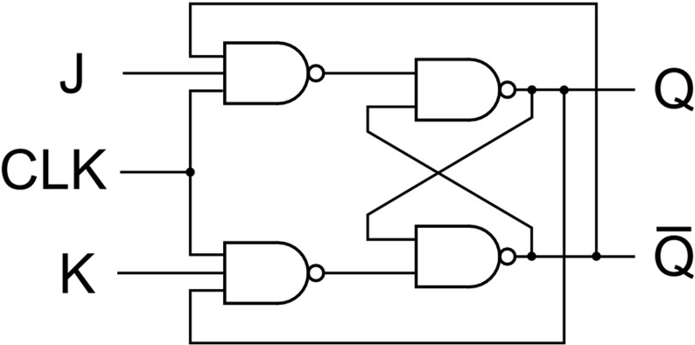
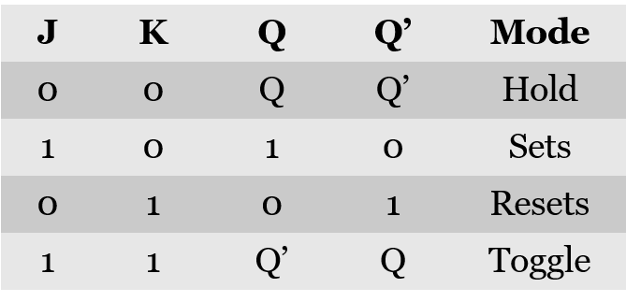

The four modes of operation are:
- Hold Mode (J=0, K=0): The output Q remains unchanged.
- Reset Mode (J=0, K=1): The output Q is forced to 0.
- Set Mode (J=1, K=0): The output Q is forced to 1.
- Toggle Mode (J=1, K=1): The output Q flips to its opposite state (if it was 0 it becomes 1, and vice-versa).
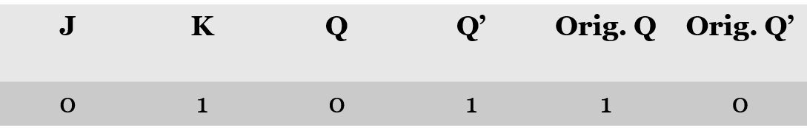
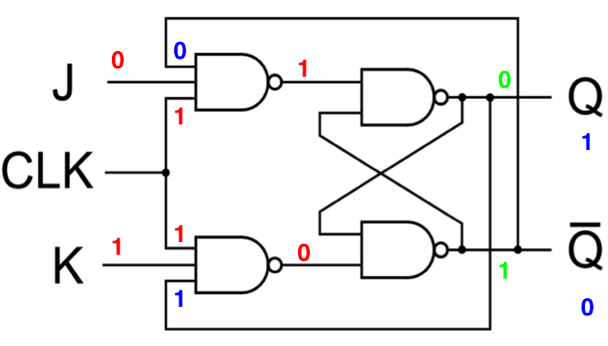
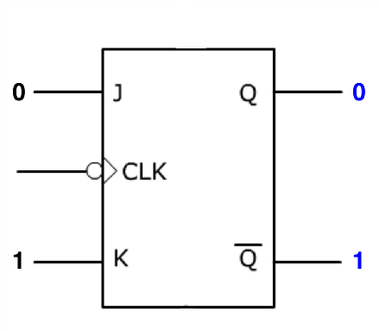
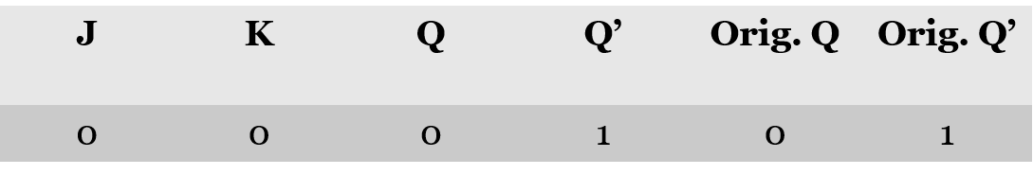
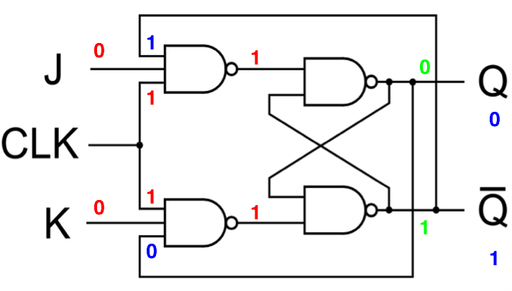
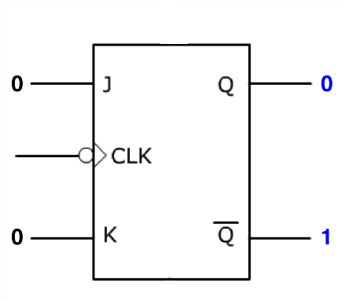
RESET
HOLD

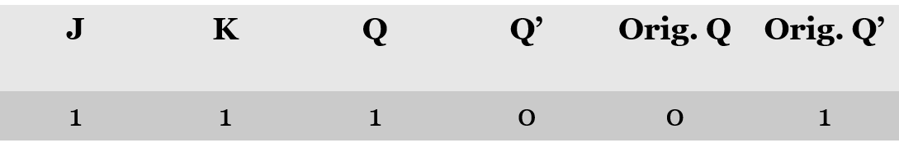
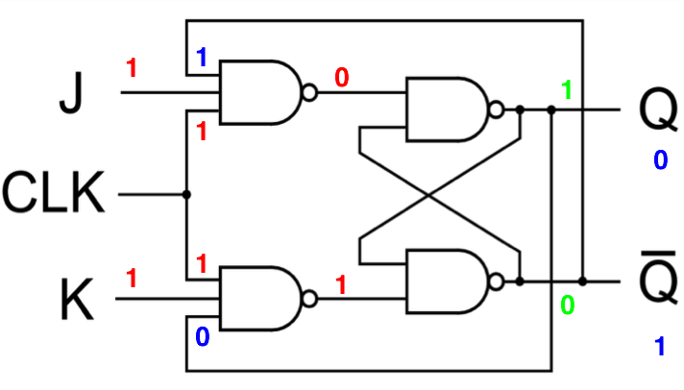
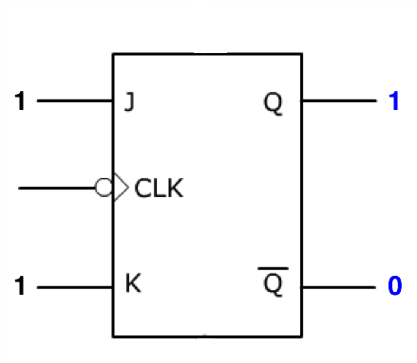
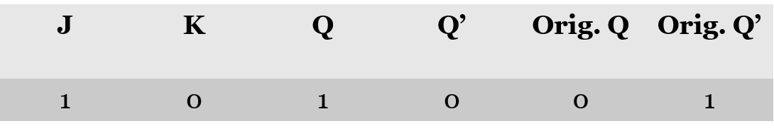
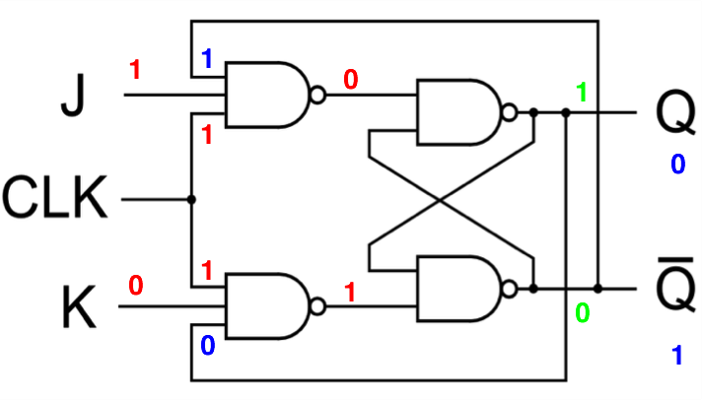
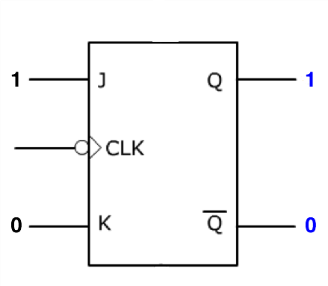
TOGGLE
SET

- Explain the race-around condition in J-K flip-flops.
Ans:
1. Where it occurs
- Found in level-triggered JK flip-flops (not edge-triggered).
- Happens when J = K = 1.
2. What it means
- Normally, when J = K = 1, the JK flip-flop should toggle (Q → Q′).
- But if the clock pulse is HIGH for too long, the output keeps toggling multiple times instead of just once.
3. Why it happens
- Because during the HIGH level of clock, the output is fed back into the input (feedback path).
- Output changes → input also changes → output changes again → continues until clock goes LOW.
- This uncontrolled toggling = race-around condition.

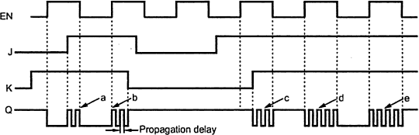
4. Effects
- The flip-flop output becomes unpredictable.
- Instead of clean toggling, output may oscillate several times.
- Final state depends on signal delays, so it cannot be trusted.
5. Conditions for occurrence
- Flip-flop is level-triggered (not edge-triggered).
- J = 1, K = 1.
- Clock pulse width > propagation delay of the flip-flop.
6. How to avoid race-around
- Edge-triggering: Use edge-triggered flip-flops instead of level-triggered.
- Master–slave JK flip-flop: Two stages ensure output toggles only once per clock pulse.

- Explain the concept of S-R latch in detail.
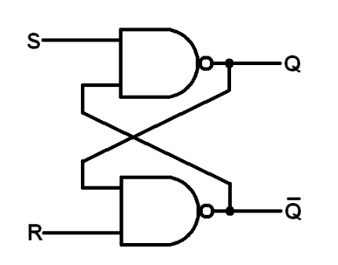
Ans:
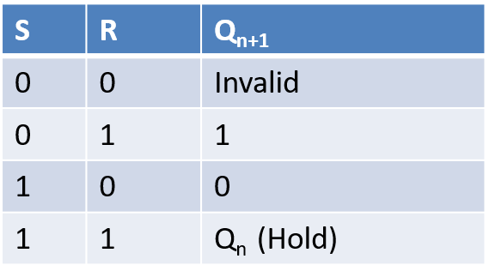

An S–R latch (Set–Reset latch) is the simplest type of flip-flop.
It is a bistable circuit made using logic gates (usually NOR or NAND gates).
It has two inputs — S (Set) and R (Reset) — and two outputs — Q and Q′ (complement of Q).
It is a level-sensitive storage element, meaning its output can change as long as the inputs are active.
Its operation for a clocked S-R flip-flop is as follows:
Set (S=1, R=0): The output Q becomes 1.
Reset (S=0, R=1): The output Q becomes 0.
Hold (S=0, R=0): The output Q retains its previous value.
Invalid (S=1, R=1): This state is forbidden as it leads to an unpredictable output.
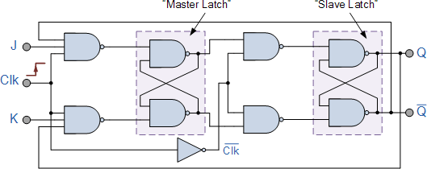
- How does a Master-Slave J-K flip-flop overcome the race-around condition?
Ans:

- A Master-Slave J-K flip-flop consists of two flip-flops connected in series: a "master" and a "slave".
- When the clock is HIGH, the master is enabled and accepts the J and K inputs, but the slave is disabled (its clock is inverted). This prevents the final output from changing.
- When the clock goes LOW, the master is disabled, locking its state. The slave then becomes enabled and copies the state from the master to the final output.
- This two-stage process ensures the output can only change once per clock cycle (on the falling edge), effectively isolating the inputs from the output during the pulse and preventing the continuous toggling of the race-around condition.

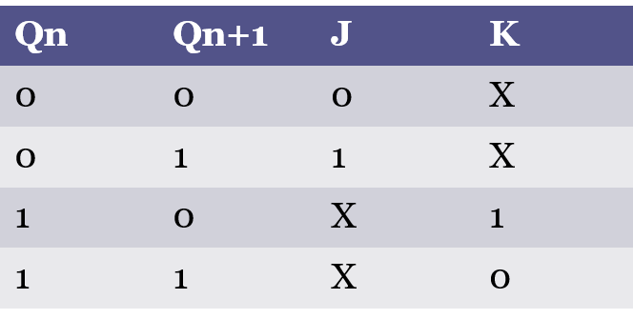
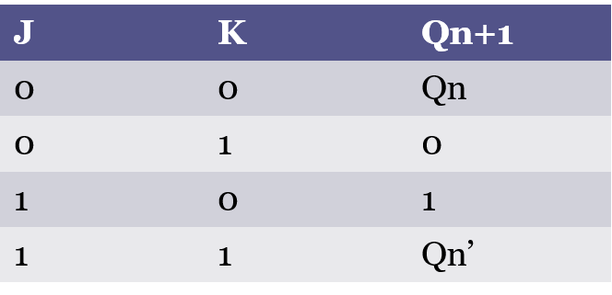
- Explain the truth table and excitation table for a J-K flip-flop.
Ans:

ET
TT

Truth Table Explanation
- When J = 0 and K = 0, the output does not change — it holds its previous state.
- When J = 0 and K = 1, the flip-flop resets, making the output Q = 0.
- When J = 1 and K = 0, the flip-flop sets, making the output Q = 1.
- When J = 1 and K = 1, the output toggles — it switches from 0 to 1 or 1 to 0 on each clock pulse.
The excitation table tells us what J and K inputs are needed to move from the present state (Qₙ) to the next state (Qₙ₊₁).
- If the output must remain the same, keep J = 0 and K = 0.
- To change from 0 to 1, apply J = 1 (set).
- To change from 1 to 0, apply K = 1 (reset).
- If you want the output to toggle each time, set both J and K = 1.

- Explain the truth table and excitation table for a S-R flip-flop.
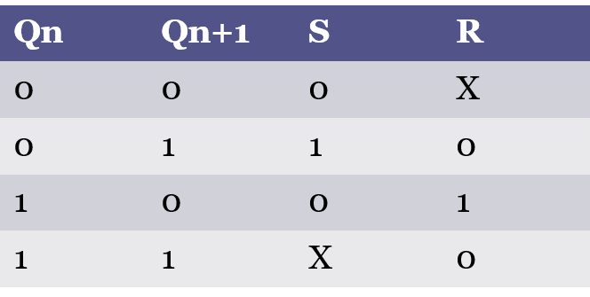
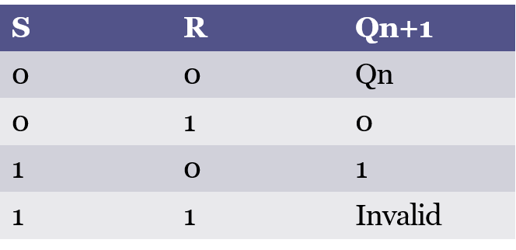
Ans:

ET
TT

Truth Table Explanation
- When S = 0 and R = 0, the flip-flop holds its previous state. The output does not change.
- When S = 1 and R = 0, the flip-flop is set, making Q = 1 and Q′ = 0.
- When S = 0 and R = 1, the flip-flop is reset, making Q = 0 and Q′ = 1.
- When S = 1 and R = 1, the state is invalid or forbidden, because both outputs become 0 temporarily, which violates the rule that Q and Q′ must be complements.
Excitation Table Explanation
- The excitation table tells us what inputs (S and R) are required to move from the present state (Qₙ) to a desired next state (Qₙ₊₁).
- To remain in the same state, keep S = 0 and R = 0.
- To change from 0 to 1, apply S = 1, R = 0 (Set).
- To change from 1 to 0, apply S = 0, R = 1 (Reset).
- The case S = 1, R = 1 is not allowed (invalid).

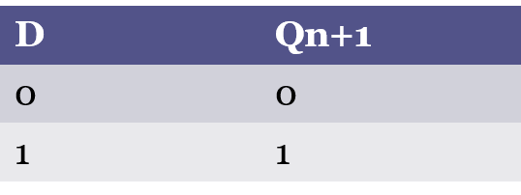
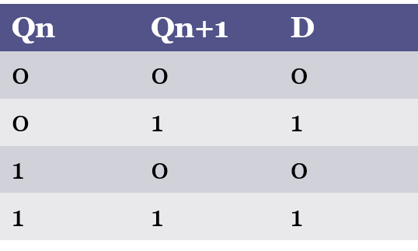
- Explain the truth table and excitation table for a D flip-flop.
Ans:

TT
ET

Truth Table Explanation
- The D flip-flop transfers the value of D (data input) to the output Q at the moment of the clock edge (usually rising edge).
- If D = 0, then Q becomes 0.
- If D = 1, then Q becomes 1.
- In other words, Qₙ₊₁ = D.
- This means the output always takes the value of the D input — it just delays it by one clock pulse.
Excitation Table Explanation
- The excitation table shows what input D is required to move from the present state (Qₙ) to the next state (Qₙ₊₁).
- If the present and next states are the same (0→0 or 1→1), then D must equal Qₙ₊₁ (no change).
- If the next state is different (0→1 or 1→0), then D must be set equal to Qₙ₊₁ (that new value).

- Explain the truth table and excitation table for a T flip-flop.
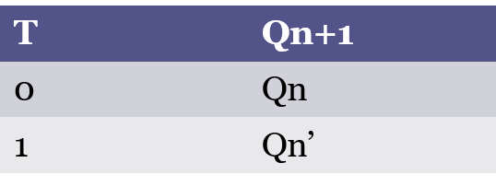
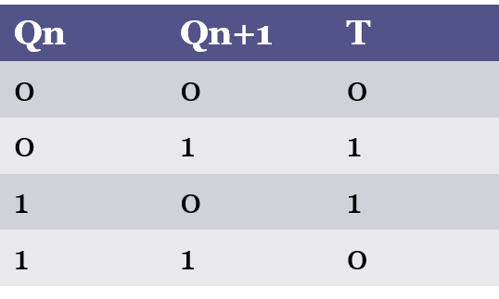
Ans:

- A T flip-flop changes its output based on the T input (Toggle input) and the current state.
- If T = 0, the flip-flop keeps its current state.
- If T = 1, the flip-flop toggles (changes from 0 → 1 or 1 → 0).
- It is basically derived from a JK flip-flop by connecting J = K = T.
- When T = 0, output Q⁺ = Q → No change.
- When T = 1, output Q⁺ = Q’ → Toggle.
- To stay in the same state (0→0 or 1→1), T must be 0.
- To toggle the state (0→1 or 1→0), T must be 1.

- List the characteristics of flip-flops.
Ans:
Characteristics of Flip-Flops
- Bistable: Flip-flops have two stable states (0 and 1), storing one bit of information.
- Memory: They act as memory elements, retaining their state until changed.
- Clocked: Most flip-flops change state based on a clock signal, making them synchronous.
- Edge- or Level-Triggered: They can be triggered by a clock edge (rising/falling) or clock level (HIGH/LOW).
- Inputs and Outputs: Common inputs include Set (S), Reset (R), and Clock (CLK), with outputs Q and Q′.
- Feedback: A feedback loop ensures the flip-flop retains its state until new input arrives.
- Types: Common types are SR, JK, D, and T flip-flops.
- Asynchronous vs. Synchronous: Asynchronous flip-flops change state immediately, while synchronous ones change only on the clock signal.
- Race Condition: Occurs in level-triggered JK flip-flops, but avoided in Master-Slave JK flip-flops.
- Timing: Flip-flops have setup and hold time requirements for stable operation.

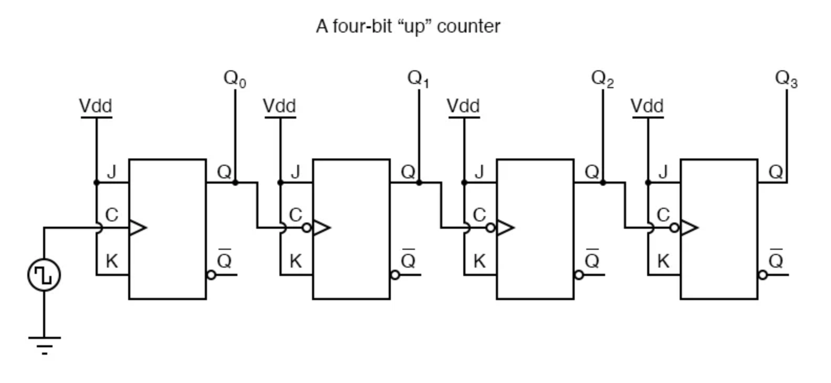
- Design asynchronous 4-bit up counter using J-K flip-flops. Show the state diagram.
Ans:

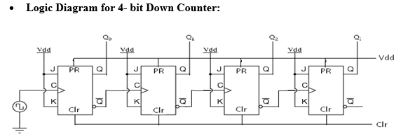
- Design asynchronous 4-bit down counter using J-K flip-flops. Show the state diagram.
Ans:

- Design a synchronous 3-bit up/down counter using J-K flip-flops. Show the state diagram.
Ans: 2 diagrams from above 2 questions.

- Convert the following flip-flops (with necessary tables and logic diagrams):
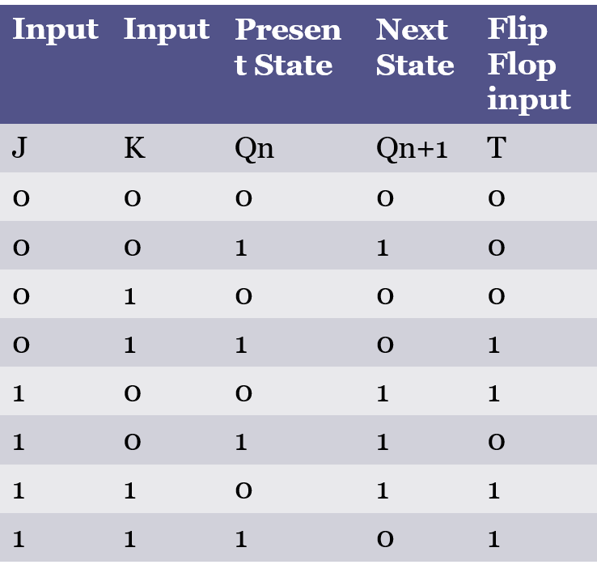
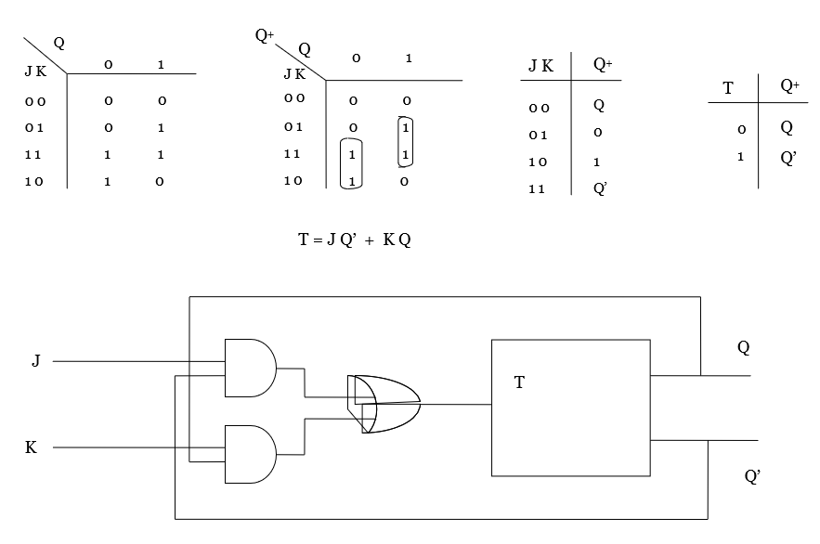
T to J-K
Ans:

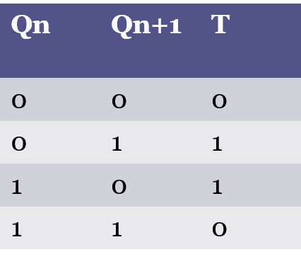

S-R to D
Ans:

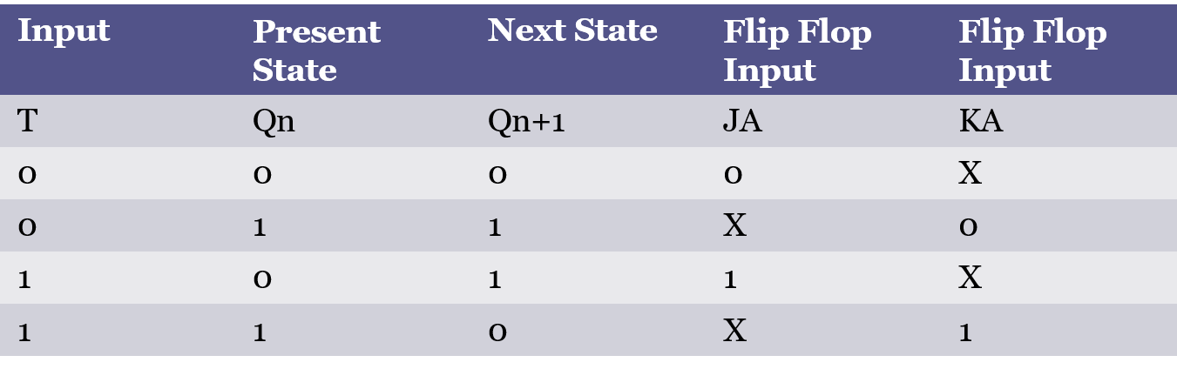
J-K to T
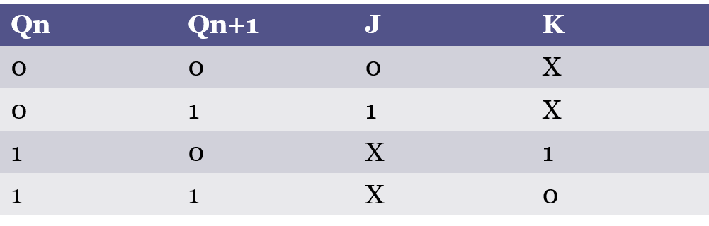
Ans:

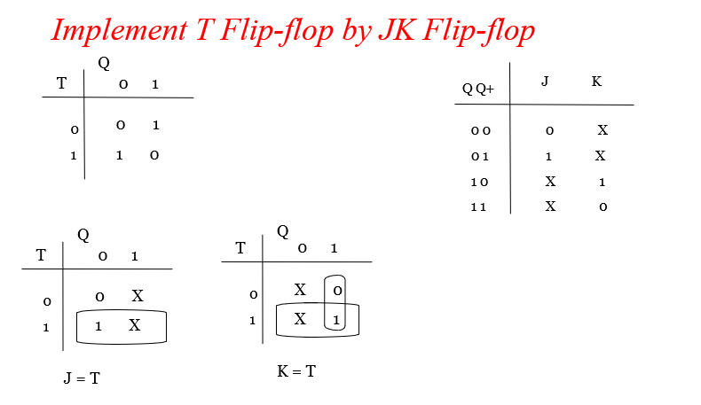

D to T
Ans:

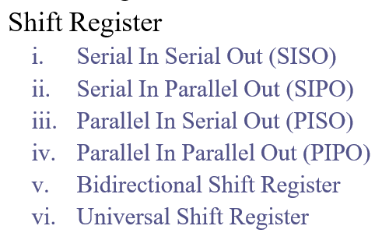
- What is register and explain the types of Shift register with diagram?
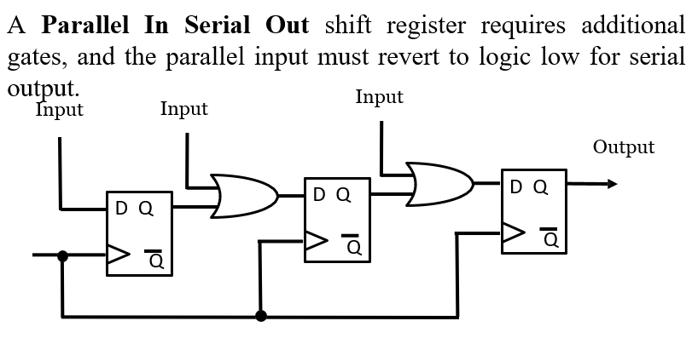
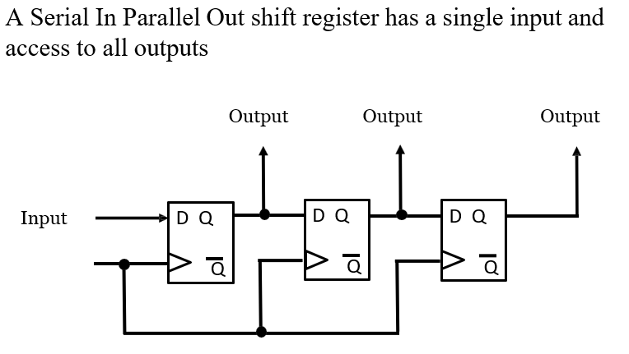
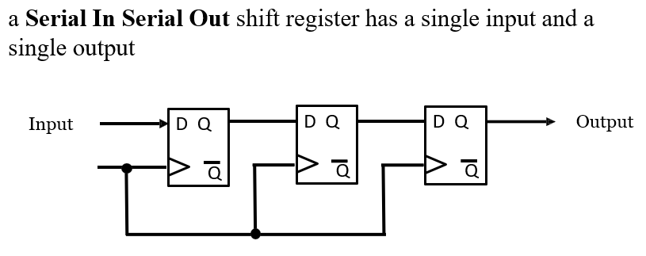
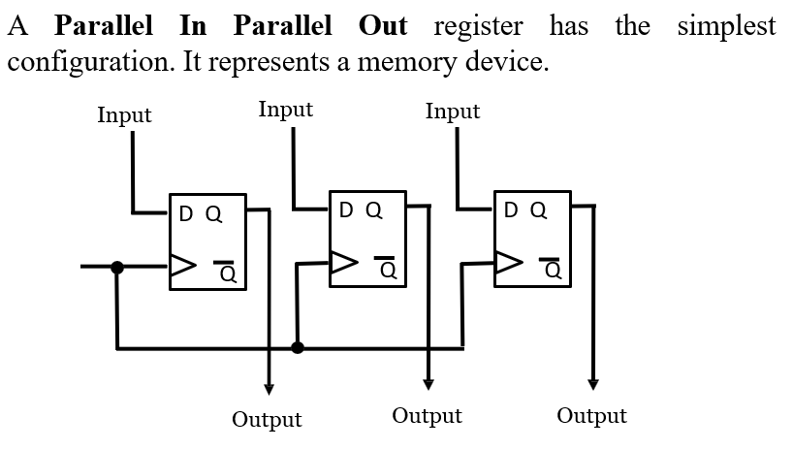
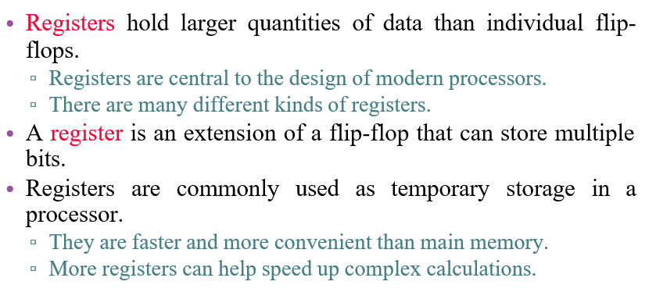
Ans:

- Write the shift register application?
Ans:
- Temporary data storage.
- Bit manipulation.
- Serial to parallel convertor.
- Parallel to serial convertor.
- Computer and Data Communications.
- Serial and Parallel Communications.
- Multi-bit number storage.
- Sequence generator.
- Sequence Detector.
- Logical operations.

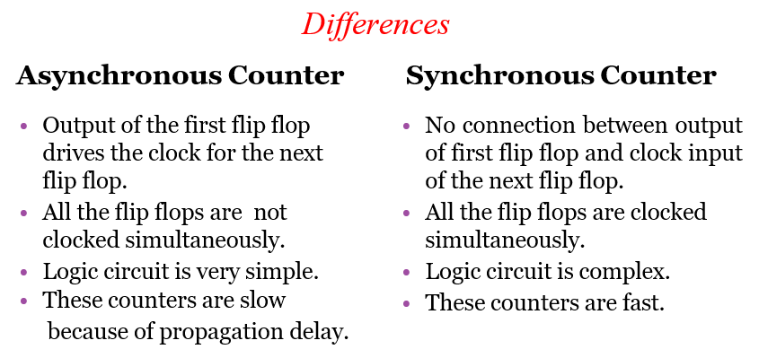
- What is difference between synchronous and asynchronous counter?
Ans:

- Show how a MOD-n counter can be derived from a basic ripple counter.
- Explain the working of J-K flip-flop with the help of a truth table and timing diagrams.
Ans:
- Used to avoid race condition which does occur in SR FF
- It has 2 inputs named J & K.
- It has two outputs Q & Q’.
- One Clock signal.
- 2 Asynchronous inputs PR & CLR

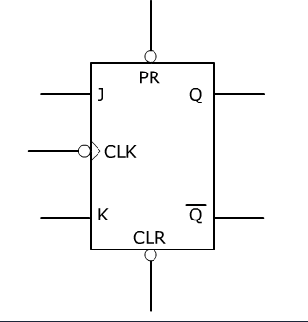
- Symbol of JK -
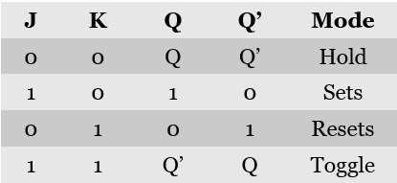

TT
- Explain the race-around problem in detail and how Master-Slave configuration solves it.
Ans:
- When J=K=1, then race around condition occurs
- It occurs, when the time period of the clock pulse (pulse width) is greater than the propagation delay of the flip flop. Due to that output changes or toggles in a single clock period.
- Propagation delay is the speed of operation of circuit.
- How to avoid it?
- We cant make clock pulse smaller than propagation delay, so to avoid it
- Q6 to refer after this

- Discuss the importance of excitation tables in sequential circuit design.
Ans:
1. Helps determine the required flip-flop inputs for specific state transitions.
2. Establishes a clear link between the current state and the desired next state.
3. Ensures correct and predictable behaviour of sequential circuits.
4. Simplifies the design of counters, registers, and finite state machines.
5. Avoids invalid or illegal input conditions in flip-flops (e.g., SR = 1,1).
6. Supports systematic conversion from state diagrams or tables to hardware logic.
7. Assists in optimizing logic circuits by minimizing the number of gates.
8. Improves reliability by clearly defining input requirements.
9. Makes troubleshooting and debugging of sequential designs easier.
10. Essential for implementing safe and accurate state machines in digital systems.

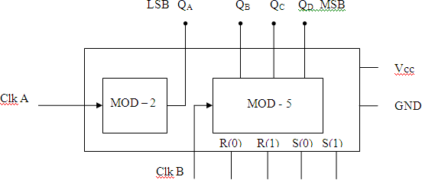
- Explain the working of IC 7490 counters with block diagrams.
Ans:
- IC 7490 is a 4-bit binary counter capable of counting from 0 to 9 (MOD-10).
- Internally, it has:
  - One divide-by-2 section (1 flip-flop)
  - One divide-by-5 section (3 flip-flops)
- The divide-by-2 section (QA) receives the external clock input.
- The output QA (÷2) is fed into the divide-by-5 section (QB, QC, QD).
- The ÷5 section divides QA further by 5.
- Together, the two sections divide the input clock by 10 (2 × 5 = 10).
- Outputs QA, QB, QC, and QD give a 4-bit binary representation of the count (0000 to 1001).
- After counting 9 (1001), the counter resets back to 0 (0000) on the next clock pulse.
- Reset inputs (R1 and R2) can be used to asynchronously clear the count to 0000.
- The counter can be used in digital clocks, timers, and event counting applications.

- Explain the working of IC 7493 counters with block diagrams.
Ans:
- It is a 4-bit asynchronous counter capable of counting from 0 to 15 (MOD-16).
- The IC has 4 outputs: QA, QB, QC, and QD — representing a binary count.
- Internally, the counter has:
  - A divide-by-2 stage (QA),
  - A divide-by-8 stage (QB, QC, QD).
- Clock input is applied to pin 14 (CP1), which drives the ÷2 stage.
- QA output is then connected to pin 1 (CP0), which feeds the ÷8 stage.
- This configuration divides the input frequency by 2 (via QA) and then by 8 → total ÷16.
- Thus, the IC counts from 0000 (0) to 1111 (15) in binary → MOD-16.
- Each output represents one bit of the count:
  - QA = LSB (Least Significant Bit)
  - QD = MSB (Most Significant Bit)
- After reaching 1111 (15), the next pulse resets the count back to 0000.
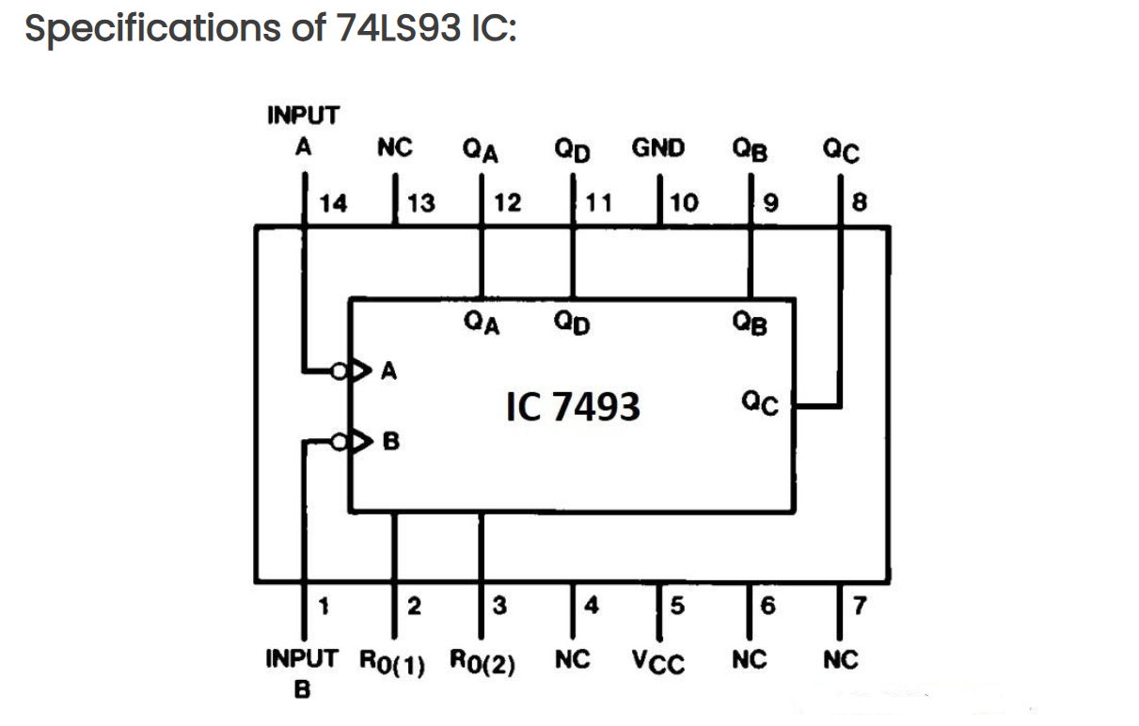
- The IC includes asynchronous Reset inputs (pins 2 & 3); applying HIGH to both resets the count to 0 immediately.

